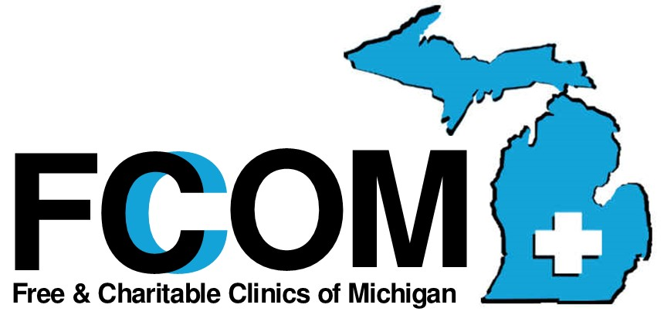

2023 MEMBERSHIP APPLICATION
Associate Members
Associate membership, without the right to vote or serve on the Board of Directors, is open to anyone interested and any organizations who wish to support the goals of Free & Charitable Clinics of Michigan. Usually this appeals to people or groups that do not offer direct healthcare or who offer healthcare but at a cost to patients with no provision for offering free care but want to support our work.

Name |  | Click here to enter your name
Address |  |  | Number and street |  |  |  | City |  |  |  |  |  | State |  |  | Zip
Mailing Address (if different) |  |  |  |  |  | Number and street |  |  |  |  | City |  |  | State |  |  | Zip
Phone |  | Phone number |  |  |  |  |  | Fax | Fax number
E-Mail |  | Email address |  |  |  |  |  | Website |  |  |  | Website address
 | Primary Contact |  |  | Primary contact name
Phone |  | Primary contact phone |  |  |  |  |  | E-Mail |  | Primary contact E-Mail
For-Profit☐ |  |  |  |  | Non-Profit☐ |  |  | If non-profit |  |  |  |  |  |  | EIN #

Why do you want to join? How will being an Associate Member benefit Michigan’s free clinics? (Use the other side of the application if needed)
Answer here using as much space as needed.

BENEFITS OF AN FCOM ASSOCIATE MEMBERSHIP
- Notification of and participation in FCOM Meetings
- Networking opportunities with Michigan’s Free Clinics
- Monthly FCOM updates and announcements
$100.00- Membership January 1 to December 31. Donations are also gratefully accepted. SEE the website donation page.
PLEASE EMAIL the COMPLETED application to Stacey Doyle stacey@gcfmc.org, and pay either by attached check or through the FCOM website www.fcomi.org/donations.

Signature/Position of Applicant | Insert Signature/Position |  | Date | Date

Free & Charitable Clinics of Michigan 100 Pine St., Ste. 175 Zeeland, MI 49464

